Step-1
http://www.adobe.com/downloads/

Step-2

Step-3

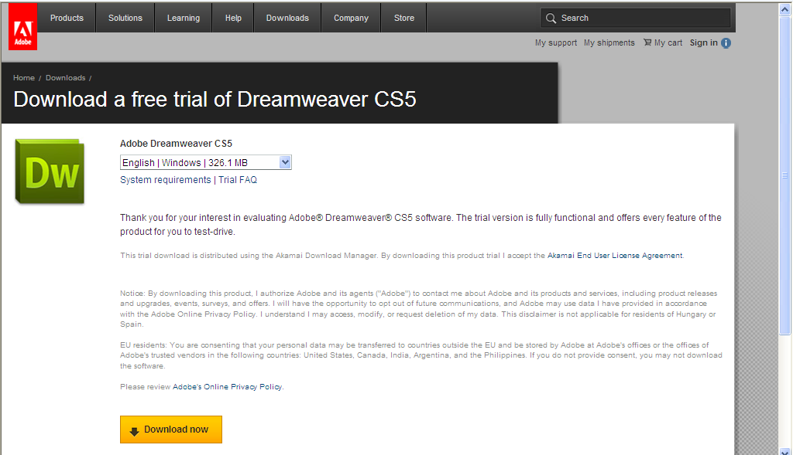

Step-4
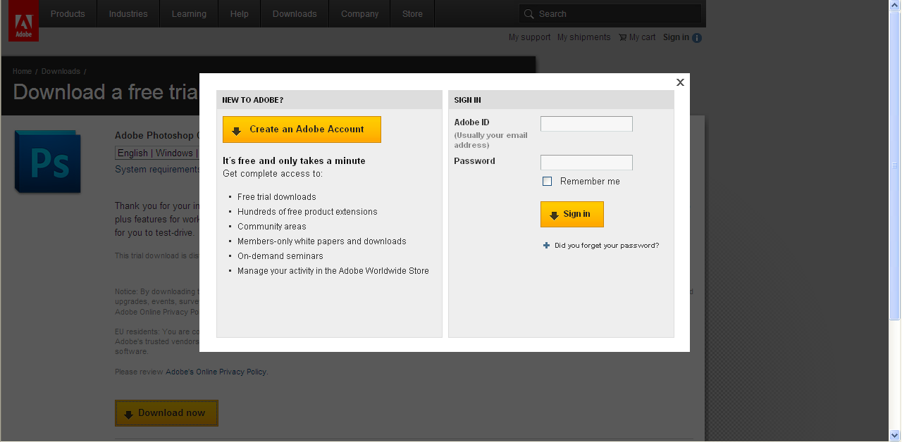

Step-5
Fill this application form

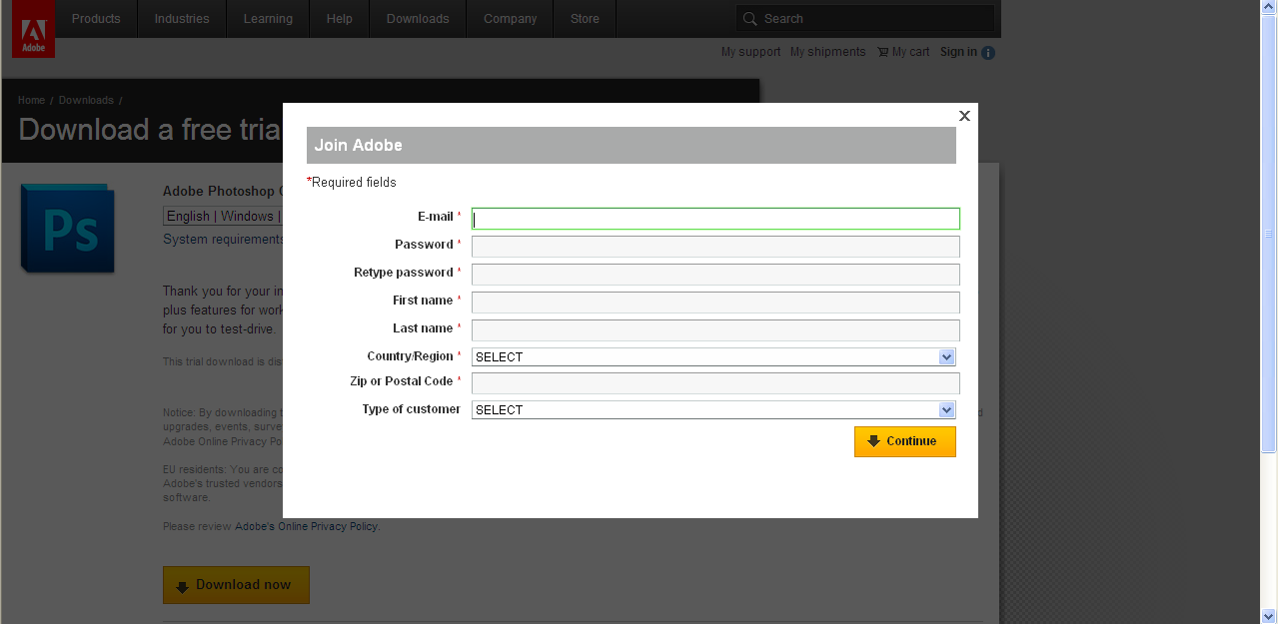

Fill your details.
Step-6
Save (download file 1)

Step-7
After saving the file, run the setup file
Thank you,
Pravin Kumar

